Salford Parish Council

2019 Newsletter

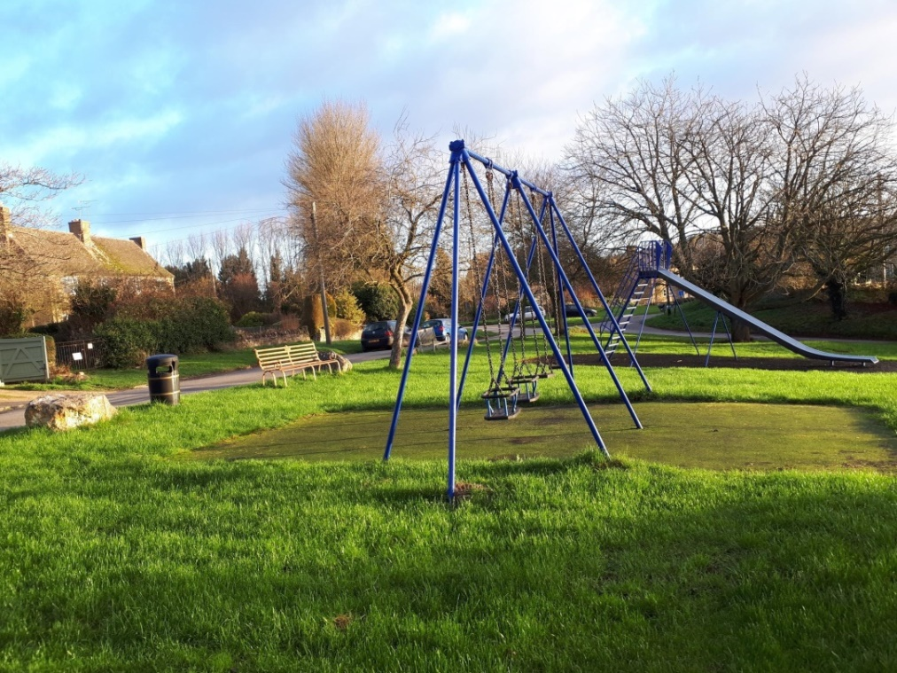

Parish Council Business 2018-19

Report by Carol Ross
Clerk & Responsible Financial Officer

Steve McBride remains Chairman of our Parish Council, the other Councillors being Nick Hill (Vice-Chairman), Rachel Caldin, Nigel Colston, and Hilary McGlynn. We meet at 7.30pm on the second Tuesday of each month in the Village Hall, and village residents are always encouraged to attend. Our County Councillor, Hilary Biles, is often present.
Current agendas, minutes, and notices of interest are displayed on the village noticeboards and also on the Parish Council website www.salfordvillage.org.uk .
Our precept (income) each year from the West Oxfordshire District Council has been the same for the last three years, and you can find our Income and Expenditure detailed on the last page of this booklet.
We have a statutory duty to be open and transparent in all matters, and you will find information about our activities, including finance and code of conduct, risk management, and planning decisions, on our website. During the last year the Parish Council has had to comply with the new Data Protection Regulations, which means ensuring that individuals’ personal data is protected and not shared without explicit consent.
There have been a few highway issues in 2018. A dip in the road outside the pub has finally been properly filled in.. A gully at the top of the village causing heavy rainwater to bypass a drain, has had three attempts at repair and we are
not convinced that the last one has succeeded – we will be

watching it! The A44 was closed outside the village in August and a non-slip surface put down on the bend; there were a few problems with access and unclear information and the Parish Council made a formal complaint to the County Council, which was partially upheld. Several issues have been reported to the Highways department which remain unresolved at the time of writing, including the street light in Orchard Close and the demolished chevron sign going north on the A44. The large green road sign indicating the right turn to Salford from the A44 has just been replaced. It was ordered in August by the County Council and has taken almost six months to be made by the manufacturer. We felt this delay was unacceptable and Councillor Biles has taken this up on our behalf.
Any member of the public can report a road problem, such as a pothole, on https://www.fixmystreet.com.
At the last Annual Parish Meeting it was suggested that a snow taskforce might be set up to enable the village roads to stay functional after heavy snow. Volunteers were recruited and in February a small team put down grit in the appropriate places a couple of hours before the snow fell. This worked very well and thanks are due to all the helpers and especially to the co-ordinator, Jonny Seccombe, and Oli Colston, who distributed the salt bags. Hopefully this team effort will be repeated in the future.
The playground is regularly inspected by Nick Hill and there is an annual RospA inspection in July. Trees are trimmed and the equipment maintained; this last year the swings and seesaw were repainted. We have been given two oak saplings from The Woodland Trust as part of a local initiative to commemorate World War 1, and they will be planted later this year. The discontinued telephone box opposite the village hall has finally been removed, and some replacement litter bins were purchased with the help of Cllr Biles using her Councillor Priority Fund; these bins will shortly be installed. We are grateful to Richard Lane for cutting the grass on the playground and around the village, and to Steve Newman and Nigel Colston for keeping the banks cut and the grass generally tidy.
Since this time last year we have looked at four planning applications; two were approved and two remain under consideration. Details are available on our website and also that of the West Oxfordshire District Council.
Parking in the village continues to be a problem, sometimes made worse by groups of walkers, and there is little we can do apart from requesting people to be as considerate as possible and to try to avoid parking on grass verges.
The pub is now being managed by Alex and Sarah and we wish them well and hope It will prove a popular asset in the village.
The draft minutes of last year’s Annual Parish Meeting will be delivered to you with this Newsletter. We hope to see a good turnout from the village at this year’s Annual Parish Meeting on Tuesday, April 9th. It is an opportunity for residents to hear reports on village activities and also from Parish, District, and County Councillors, and to ask questions of their Councillors should they wish to do so.

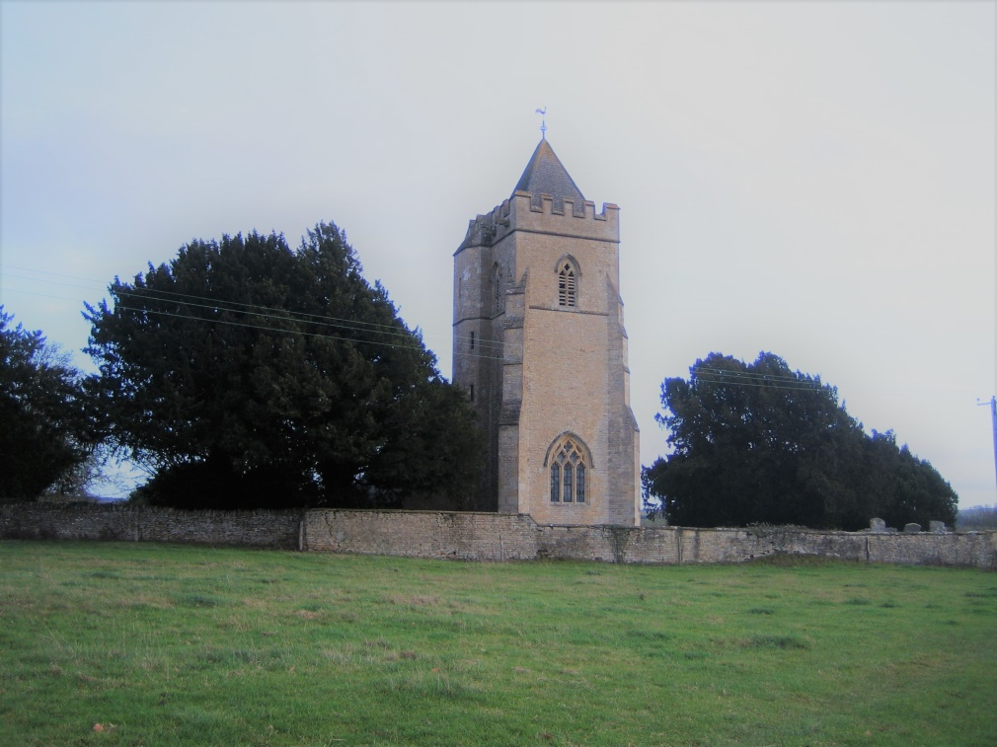

St Mary’s Church
Report from Sally and Nick Chambers
Churchwardens

The Village Church Council and Parochial Church Council have met at regular intervals (weather permitting) to ensure the smooth running of our Church.
We were very much helped in covering our outgoings by the wonderful Chastleton Teas team and cake makers as well as by a very generous donation from the car boot sale. All this came with the ceaseless care of church and graveyard given by our loyal flower arrangers, cleaners and mowers. Visitors often comment upon how nice everything looks.
We observed the centenary of the end of the First World War.
The Christmas and carol services were happy occasions and included a well attended Heythrop Hunt Carol Service.
James Kennedy continued to take our services with a much appreciated team. We are also very grateful to Rosemary Roberts who plays the organ for us.
There were two weddings and an internment of ashes.
We look forward to Easter.

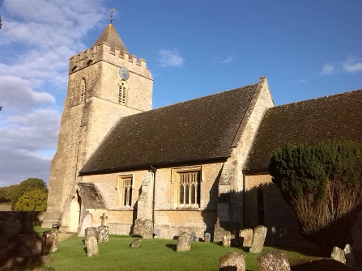

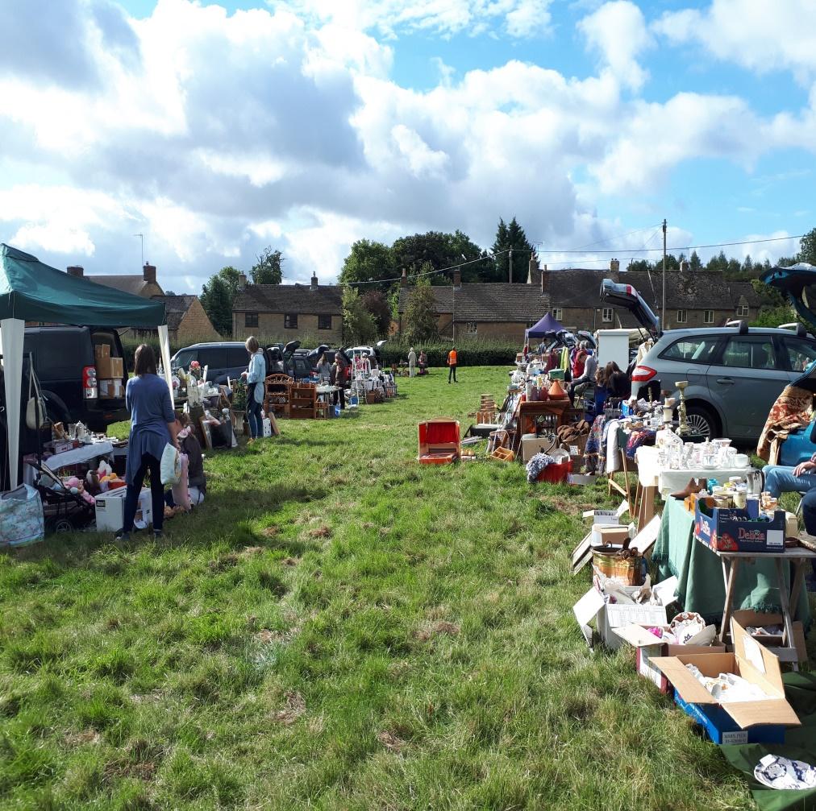

Car Boot Sale : 9 September 2018

Salford Village Hall
Report from Willie Ross
Chairman: Village Hall Committee

Once again, I’m pleased to be able to report that the Village Hall continues to be in good shape, both structurally and financially. Apart from committee members, we are very grateful to those who contribute so much towards this on a voluntary basis: Ray Timms, for his continuing grass cutting and ground clearing, Nigel Colston for arranging the gravel delivery and spreading and also for his masterly quiz questions, and Steve McBride for once again donating the Christmas tree.
Our income comes not only from regular hire fees, but also from activities organised by the committee. Our regular Quiz Night raised a net £462 plus a donation of £58 (being half the raffle takings) to the Lawrence Home Nursing Team (LHNT). And, as there was not to be a Village Fete, the “Cotswold Car Boot” event, masterminded by PJ Seccombe, was staged in its place. This raised a net £1400 for Village Hall funds, in addition to donations of £1400 to the Church and £787 for LHNT. And once again we are extremely grateful to the Parish Council for their donation of £700. All these funds are deposited in the Hall’s Maintenance Account for future need.
Following the introduction last year of the General Data Protection Regulations, the Hall now has its own computer and mobile phone for bookings and enquiries, and during the coming year we shall be looking for someone new to take over the role of Bookings Manager.
Bookings for the hall continue to be reasonably buoyant with around 36 hours per month used by regulars and a consistent number of private bookings, including the valuable NCT

Courses. The hall is equipped with tables and chairs for 80, with ample crockery, cutlery, and glasses, plus a piano, two table tennis tables, and indoor cricket nets. Rates are £7.50 per hour for Salford residents; £15 per hour others. Enquiries to 07377 784680 or salfordvillagehallevents@gmail.com
Our thanks are due to all members of the Committee for their support and assistance throughout the year: Jo Cloughley, Tim Dowling (Treasurer), Sue King, Nicki McBride, Sylvie McKay, PJ Seccombe and (recently joined from The Salford Inn) Sarah Thornley.

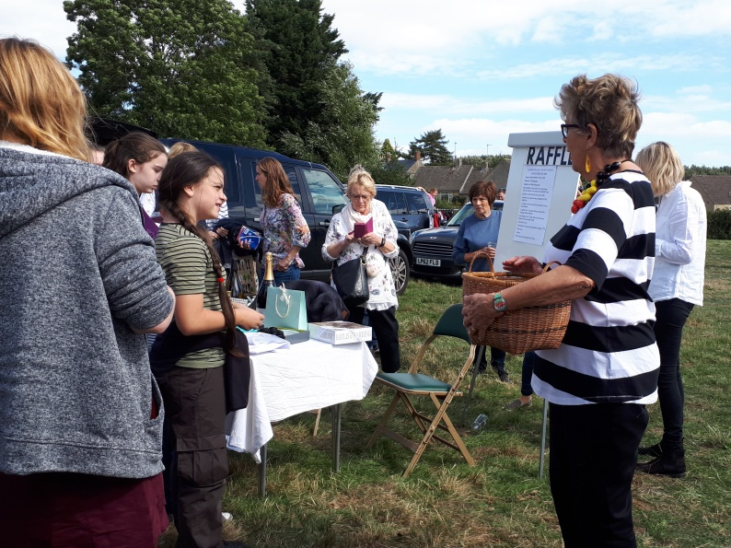

Car Boot Sale : Prue Leith drawing the Raffle

Salford Parish Council: 2018-19 Income & Expenditure (unaudited)

Income 1.4.18-31.3.19  Income £  Opening balance 3869  Precept 6750  VAT refund 267  Grass-cutting grant 462  Councillor’s Fund 368  Total Income 11716  Balance to carry forward £5250 | Expenditure 1.4.18-31.3.19  Expenditure £  Insurance 310  OALC subscription 135 Newsletter copying 30 Internal auditor 135  Grass-cutting 371  Clerk’s salary (incl PAYE) 2678  Clerk’s expenses 55  Clerk training course 54  Printing ink & laptop mouse 76  Mowing repair/service 292  RoSPA Playground inspection 80  Website annual fee 150  Village hall hire 77  Remembrance Day donation 27  Litter bins 441  Information Commissioner 35  Village Hall hire 70  Donation Villager Bus (S106A) 750  Donation Village Hall (S133) 700  Total expenditure 6466

.

Salford Parish Council

www.salfordvillage.org.uk

Clerk and Responsible Financial Officer:

Mrs Carol Ross
The School House
Salford, OX7 5FE
01608 641414
clerk@salfordvillage.org.uk

